ML Activity (2) - 230701191
February 2, 2026
[ ]:
#FOML ACTIVITY 2
#NAME:R Mohana Priya
#ROLL NO.: 230701191
import
pandas
as
pd
import
numpy
as
np
from
sklearn
.
preprocessing
import
MinMaxScaler, StandardScaler
import
seaborn
as
sns
import
matplotlib
.
pyplot
as
plt
df
=
pd
.
read_csv(
r
"
C:
\
Users
\
Mohana Priya R 191
\
Downloads
\
archive (1)
\
Housing.
↪
csv
"
)
df
.
head(
5
)
#Dataset importing
[ ]: price area bedrooms bathrooms stories mainroad guestroom basement \
0 13300000 7420 4 2 3 yes no | no
1 12250000 8960 4 4 4 yes no | no
2 12250000 9960 3 2 2 yes no | yes
3 12215000 7500 4 2 2 yes no | yes
4 11410000 7420 4 1 2 yes yes  hotwaterheating airconditioning parking prefarea furnishingstatus  - no yes 2 yes furnished  - no yes 3 no furnished  - no no 2 yes semi-furnished  - no yes 3 yes furnished | yes
4
no
yes
2
no
furnished
[4]:
#Nul handling
df
.
info()
print
(
df
.
isnull()
.
sum())
#No null found.If found use mean,median,mode based upon
␣
↪
the coloumn.Eg:if age majorly
<
class 'pandas.core.frame.DataFrame'
>
RangeIndex: 545 entries, 0 to 544 Data columns (total 13 columns):
# Column Non-Null Count Dtype
--- ------ -------------- -----
0 price 545 non-null | int64
1 area 545 non-null | int64
2 bedrooms 545 non-null | int64
3 bathrooms 545 non-null | int64
4 stories 545 non-null | int64
5 mainroad 545 non-null | object
6 guestroom 545 non-null | object
7 basement 545 non-null | object
8 hotwaterheating 545 non-null | object
9 airconditioning 545 non-null | object
10 parking 545 non-null | int64
11 prefarea 545 non-null | object
12 furnishingstatus 545 non-null dtypes: int64(6), object(7)  memory usage: 55.5+ KB  price 0 area 0 bedrooms 0 bathrooms 0 stories 0 mainroad 0 guestroom 0 basement 0 hotwaterheating 0 airconditioning 0 parking 0 prefarea 0 furnishingstatus 0 | object
dtype: int64
[5]:
binary_cols
=
[
'
mainroad
'
,
'
guestroom
'
,
'
basement
'
,
'
hotwaterheating
'
,
'
airconditioning
'
,
'
prefarea
'
]
for
col
in
binary_cols:
df[col]
=
df[col]
.
map({
'
yes
'
:
1
,
'
no
'
:
0
})
#Binary encoding
[6]:
df
=
pd
.
get_dummies(df, columns
=
[
'
furnishingstatus
'
]
, drop_first
=
True
)
#One-Hot
␣
↪
Encoding for Furnishing Status
[7]:
df
.
describe()
[7]: price area bedrooms bathrooms stories \ count 5.450000e+02 545.000000 545.000000 545.000000 545.000000 mean 4.766729e+06 5150.541284 2.965138 1.286239 1.805505 std 1.870440e+06 2170.141023 0.738064 0.502470 0.867492 min 1.750000e+06 1650.000000 1.000000 1.000000 1.000000
25% | 3.430000e+06 3600.000000 | 2.000000 | 1.000000 | 1.000000
50% | 4.340000e+06 4600.000000 | 3.000000 | 1.000000 | 2.000000
75% | 5.740000e+06 6360.000000 | 3.000000 | 2.000000 | 2.000000
max | 1.330000e+07 16200.000000 | 6.000000 | 4.000000 | 4.000000
mainroad guestroom basement hotwaterheating airconditioning \
count 545.000000 545.000000 545.000000 |  | 545.000000 | 545.000000
mean 0.858716 0.177982 | 0.350459 | 0.045872 | 0.315596
std 0.348635 0.382849 | 0.477552 | 0.209399 | 0.465180
min 0.000000 0.000000 | 0.000000 | 0.000000 | 0.000000
25% 1.000000 0.000000 | 0.000000 | 0.000000 | 0.000000
50% 1.000000 0.000000 | 0.000000 | 0.000000 | 0.000000
75% 1.000000 0.000000 | 1.000000 | 0.000000 | 1.000000
max 1.000000 1.000000  parking prefarea  count 545.000000 545.000000 mean 0.693578 0.234862 std 0.861586 0.424302 min 0.000000 0.000000 25% 0.000000 0.000000  50% 0.000000 0.000000 75% 1.000000 0.000000 max 3.000000 1.000000 | 1.000000 | 1.000000 | 1.000000
[8]: plt.figure(figsize=(10, 6)) sns.boxplot(data=df[['price', 'area', 'bedrooms', 'bathrooms', 'stories',␣
↪'parking']]) plt.xticks(rotation=45) plt.show()#The boxplot shows that house price has a wide spread with several␣ ↪high-value outliers, indicating significant variation in property prices.
#Other features like area, bedrooms, bathrooms, stories, and parking have␣ ↪comparatively smaller ranges, meaning they are more uniformly distributed␣ ↪with fewer extreme values. 3
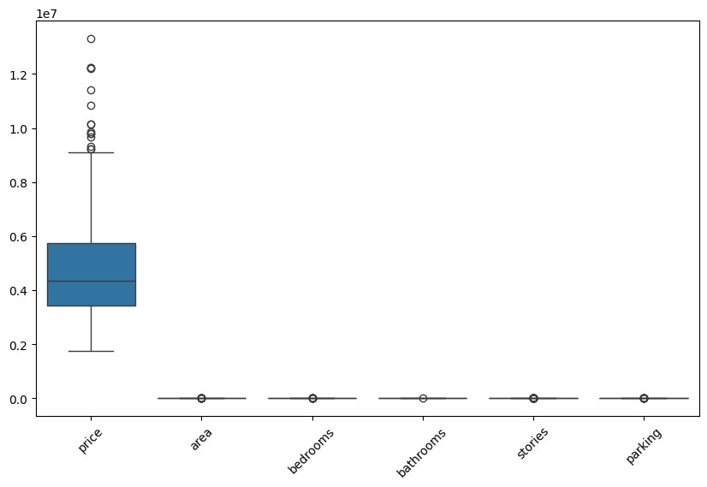
[16]: #These histograms show the distribution of numerical features.Price and area␣ ↪are right-skewed, while other features have limited discrete values. num_cols = ['price', 'area', 'bedrooms', 'bathrooms', 'stories', 'parking']
df[num_cols].hist(figsize=(12, 8), bins=20) plt.tight_layout() plt.show()
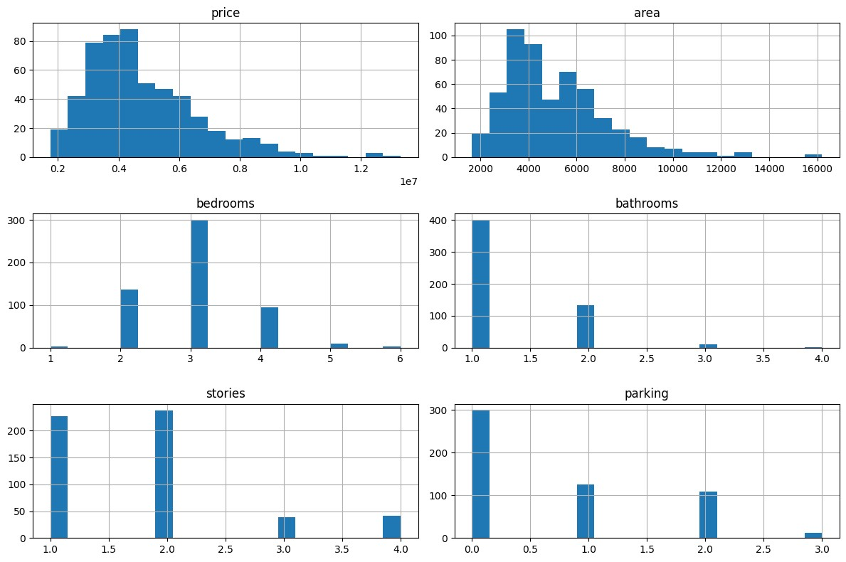
[17]: sns.pairplot(df[num_cols]) plt.show()
#This plot visualizes pairwise relationships between numerical features.A␣ ↪positive relationship is observed between area and price.
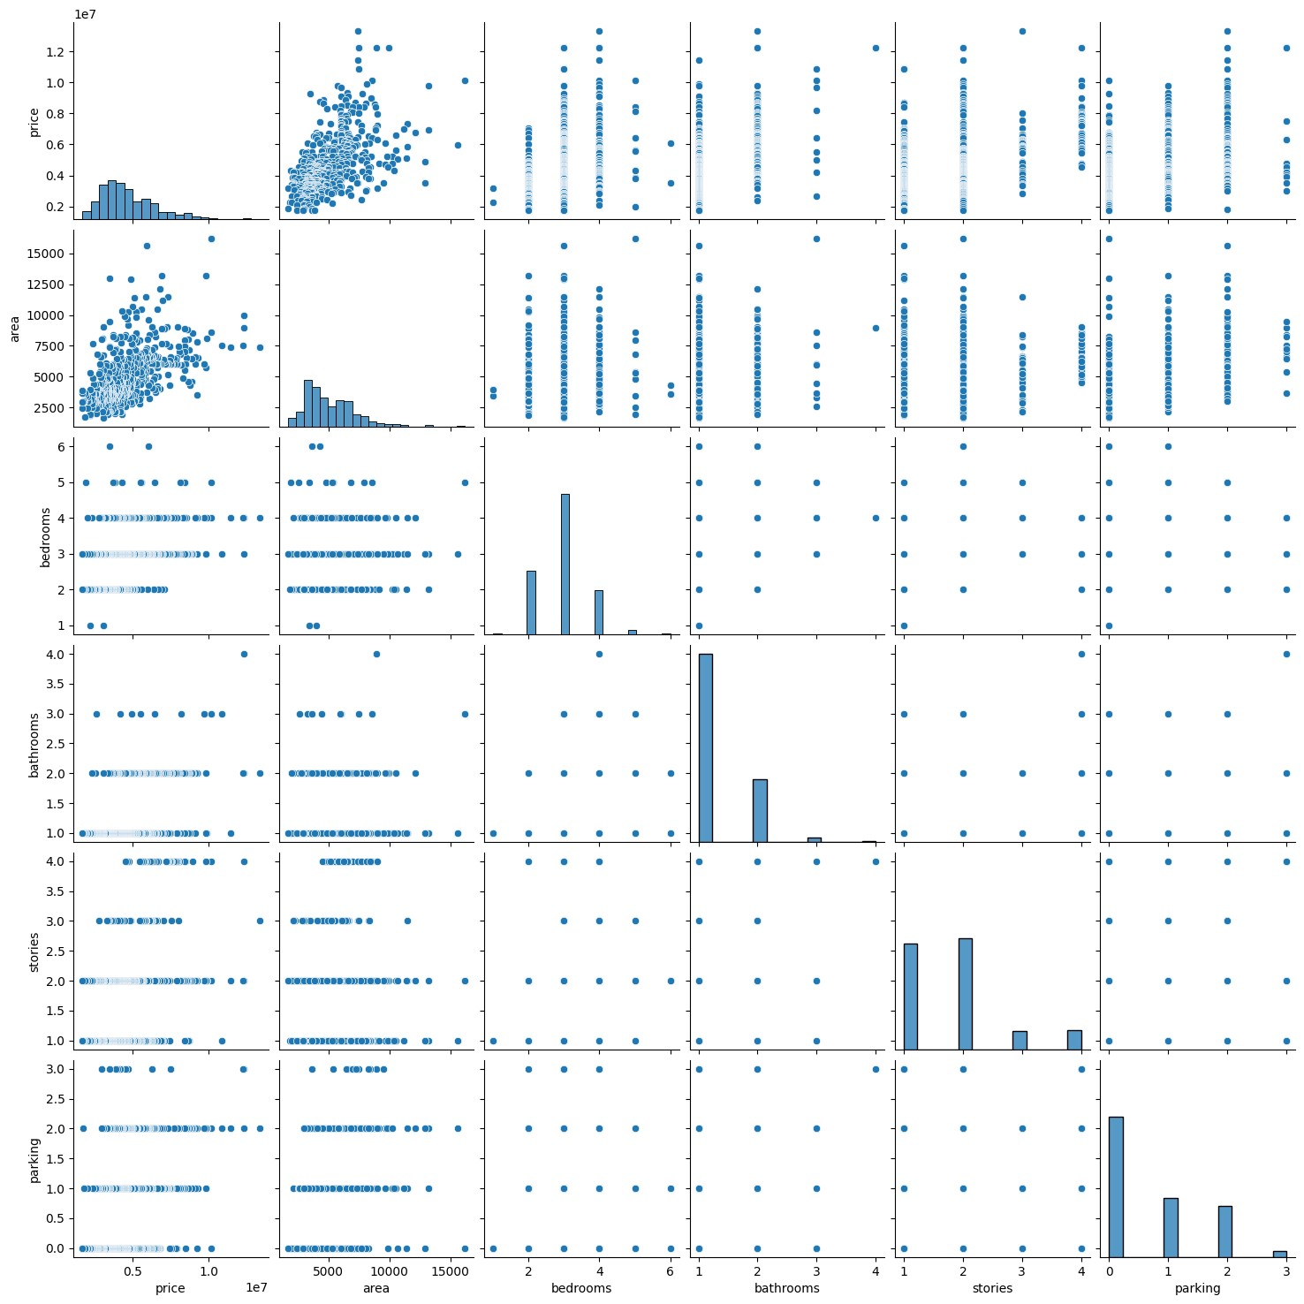
[10]:
#OUTLIER DETECTION
#Outlier Removal Using the IQR Method
Q1
=
df[
'
price
'
]
.
quantile(
0.25
)
Q3
=
df[
'
price
'
]
.
quantile(
0.75
)
IQR
=
Q3
-
Q1
lower_bound
=
Q1
-
1.5
*
IQR
upper_bound
=
Q3
+
1.5
*
IQR
df
=
df[(df[
'
price
'
]
>
=
lower_bound)
&
(
df
[
'
price
'
]
<
=
upper_bound)]
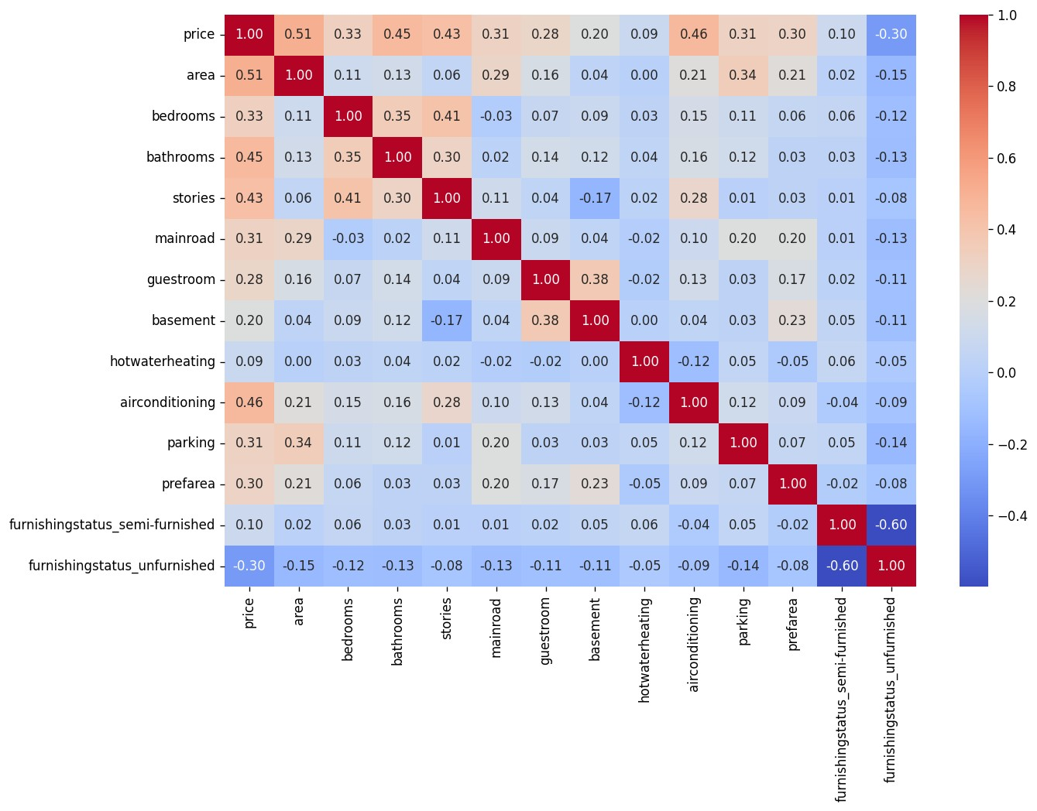
[11]:
#Correlation Analysis
corr
=
df
.
corr()
plt
.
figure(figsize
=
(
12
,
8
)
, dpi
=
120
)
sns
.
heatmap(corr, annot
=
True
, cmap
=
'
coolwarm
'
, fmt
=
'
.2
f
'
)
plt
.
show()
print
(
corr
[
'
price
'
]
.
sort_values(ascending
=
False
))
price | 1.000000
area | 0.512801
airconditioning | 0.458907
bathrooms | 0.452676
stories | 0.430699
bedrooms | 0.326890
parking | 0.312787
mainroad | 0.311438
prefarea | 0.301001
guestroom | 0.283291
basement 0.195148 furnishingstatus_semi-furnished 0.095927 hotwaterheating 0.089984 furnishingstatus_unfurnished -0.295681
Name: price, dtype: float64
[12]:
#Separate Features and Target Variable
X
=
df
.
drop(columns
=
[
'
price
'
])
y
=
df[
'
price
'
]
[13]:
#Normalization
#Min Max Scaler
scaler
=
MinMaxScaler()
X_normalized
=
scaler
.
fit_transform(X)
print
(
X_normalized
[:
5
])
[[0.34193548 0.4
0.5
0.33333333 1.
0.
0. 0.  0. ] | 1. | 0.33333333 1. | 1.
[0.19139785 0.4 | 0. | 0.33333333 1. | 0.
1. 1.  0. ] | 0. | 0.66666667 0. | 1.
[0.39462366 0.4 | 0.5 | 0. 1. | 1.
1. 0.  1. ] | 1. | 0.66666667 0. | 0.
[0.45878136 0.4 | 0. | 0. 1. | 1.
1. 0.  0. ] | 1. | 0.33333333 0. | 0.
[0.20860215 0.4 | 0.5 | 0.33333333 1. | 1.
1. 0. | 1. | 0.33333333 0. | 0.
0.
]]
[14]:
#Standardization
#Z-Score Scaling
scaler
=
StandardScaler()
X_standardized
=
scaler
.
fit_transform(X)
print
(
X_standardized
[:
5
])
[[ 0.65989599 0.08337519 1.60839991 0.25257612 0.41411617 -0.45737884 -0.72737182 -0.21383556 1.51926828 0.40988744 1.8696862 1.17936809 -0.70609879]
[-0.35247335 0.08337519 -0.55532989 0.25257612 0.41411617 -0.45737884
1.37481267 4.67649069 -0.6582116 1.60105204 -0.53484911 1.17936809 -0.70609879]
[ 1.01422526 0.08337519 1.60839991 -0.91281895 0.41411617 2.18637137
1.37481267 -0.21383556 1.51926828 1.60105204 -0.53484911 -0.8479117
1.41623243]
[ 1.44568743 0.08337519 -0.55532989 -0.91281895 0.41411617 2.18637137
1.37481267 -0.21383556 1.51926828 0.40988744 -0.53484911 -0.8479117 -0.70609879]
[-0.236774 0.08337519 1.60839991 0.25257612 0.41411617 2.18637137
1.37481267 -0.21383556 1.51926828 0.40988744 -0.53484911 -0.8479117 -0.70609879]]

